Complaint Form for Children and Young People
We try our best, but sometimes things don’t go as planned. We want you to tell us if we do something wrong. You can make a complaint about:
        - Our service
        - Our staff
        - How you were treated
        - Something else?
You have the right to:

        - Be treated fairly and with respect
        - Be safe and feel safe
        - Say exactly how you feel and be heard
        - Tell someone if you are unhappy
When you make a complaint, we will:
- Listen to you
- Try to help
- Be kind and respectful
- Tell you how long it will take for us to get back to you

If you need help when using this form, you can call NI-Connect on +6723 23380
TELL US ABOUT YOU!
full name: _ _ _ _ _ _ _ _ _ _ _ _ _ _ _ _ _ _ _ _ _ _ _ _ _ _ _ _ _
Address: _ _ _ _ _ _ _ _ _ _ _ _ _ _ _ _ _ _ _ _ _ _ _ _ _ _ _ _ _
Contact #: _ _ _ _ _ _ _ _ _ _ _ _ _ _ _ _ _ _ _ _ _ _ _ _ _ _ _ _ _ _ _
email: _ _ _ _ _ _ _ _ _ _ _ _ _ _ _ _ _ _ _ _ _ _ _ _ _ _ _ _ _ _ _ _ _ _ _ _ _ _

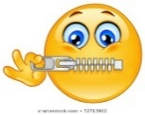
We will key your complaint private. Private means we keep your details safe!

Tell us about your complaint

Who or what are you unhappy with? Tell us what happened.
_ _ _ _ _ _ _ _ _ _ _ _ _ _ _ _ _ _ __ _ _ _ _ _ _ _ _ _ _ _ _ _ _ _ _ _ _ _ _ _ _ _ _ _ _ _ _ _ _ _ _ _ _ _ _ _ _ _ _ _ _ _ _ _ _ _ _ _ _ _ _ _ _ _ _ __ _ _ _ _ _ _ _ _ _ _ _ _ _ _ _ _ _ _ _ _ _ _ _ _ _ _ _ _ _ _ _ _ _ _ _ _ _ _ _ _ _ _ _ _ _ _ _ _ _ _ _ _ _ _ _ _ _ _ _ _
_ _ _ _ _ _ _ _ _ _ _ _ _ _ _ _ _ _ _ _ _ _ _ _ _ _ _ _ _ _ _ _ _ _ _ _ _ _ _ _ _ _ _ _ _ _
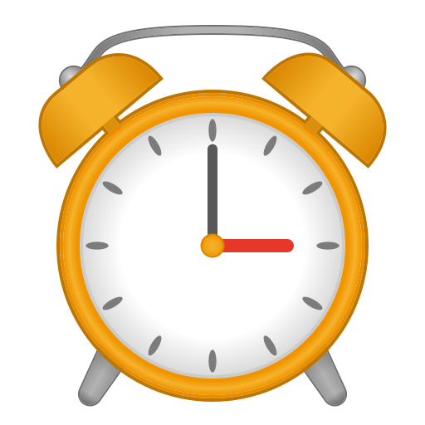
When did it happen?
_ _ _ _ _ _ _ _ _ _ _ _ _ _ _ _ _ _ __ _ _ _ _ _ _ _ _ _ _ _ _ _ _ _ _ _ _ _ _ _ _ _ _ _ _ _ _ _ _ _ _ _ _ _ _ _ _ _ _ _ _ _ _ _ _ _ _ _ _ _ _ _ _ _ _ __ _ _ _ _ _ _ _ _ _ _ _ _ _ _
What would make you happy? Tell us what you would like to happen.
_ _ _ _ _ _ _ _ _ _ _ _ _ _ _ _ _ _ __ _ _ _ _ _ _ _ _ _ _ _ _ _ _ _ _ _ _ _ _ _ _ _ _ _ _ _ _ _ _ _ _ _ _ _ _ _ _ _ _ _ _ _ _ _ _ _ _ _ _ _ _ _ _ _ _ __ _ _ _ _ _ _ _ _ _ _ _ _ _ _ _ _ _ _ _ _ _ _ _ _ _ _ _ _ _ _ _ _ _ _ _ _ _ _ _ _ _ _ _ _ _ _ _ _ _ _ _ _ _ _ _ _ _ _ _ _ _ _ _ _ _ _ _ _ _ _ _ _ _ _ _ _ _ _ _ _ _ _ _ _ _ _ _ _ _ _ _ _ _ _ _ _ _ _ _ _ _ _ _ _ _ _ _
We might need to talk to you to help fix your problem. Are you okay with this?
(Please circle)

Yes! No, thanks!
You can return this form in person to any staff member at NI-Connect, via post, website, or email, on our contact details below:
In person: Bounty Centre, Taylors Road, Norfolk Island
Post: PO Box 972 Norfolk Island 2899
Email: ChildWelfareOfficer@keyassets.com.au
Website: https://NI-connect.net
Below are other people you can talk to about your complaint:
Norfolk Island Service Director  Postal address: Key Assets, Level 1, 8 Lord Street, Botany NSW 2019  Phone: 02 8336 5700  Email: james.isles@keyassets.org.au  Child Welfare Officer (CWO)  Postal address: Suite 1B, Level 8, 111 Philip Street, Parramatta 2150  Phone: 02 8336 5700 Mobile: 0488 444 766  Email: jamie.hodgson@Keyassets.org.au | Department of Infrastructure, Transport, Regional Development, Communications and the Arts First contact the area you have been dealing with to solve the problem. If the complaint has not been resolved contact the Governance Section by email at clientservice@infrastructure.gov.au OR  Postal Address: GPO Box 594, Canberra ACT 2601  If not satisfied with the outcome of your complaint, then contact:  Commonwealth Ombudsman:  Postal Address: GPO Box 442, Canberra ACT 2601  Phone: 1300 362 072 Online Complaints Form: Web Form Submission (ombudsman.gov.au)

